* If we have the column data like in this pattern we use the replace function to give shortcuts to entire notebook.

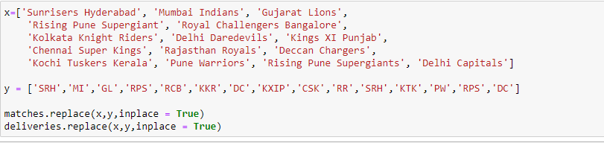

* If we have so many columns in the data set than we want to see some particular columns based on analytics we can use the dictionaries plotly output.

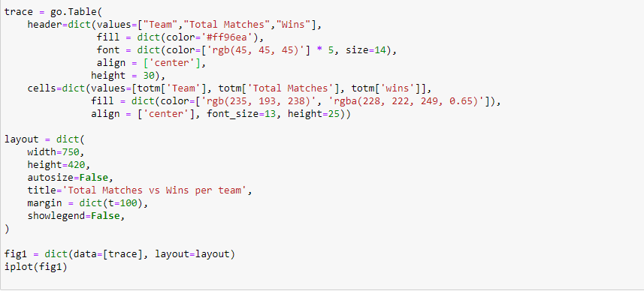

Then output will get like this above code.

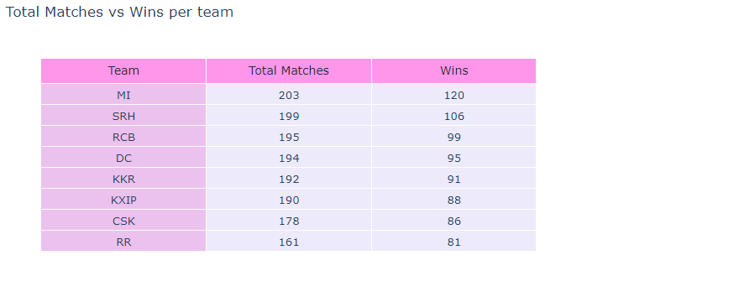

* If we use the group by in Jupyter we use this type of syntax

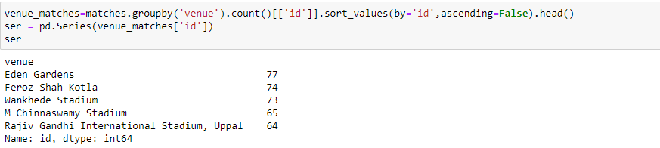

If the data like in social media kind of comments we seen in that we use case sensitives, special characters, Unnecessary Spaces, Small images etc. Then Clean the data as With any kind of this use this Reg Ex to sort out this problems

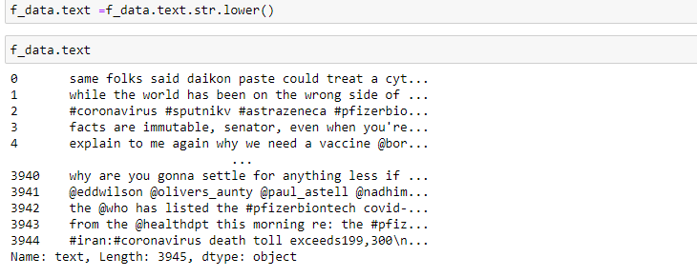

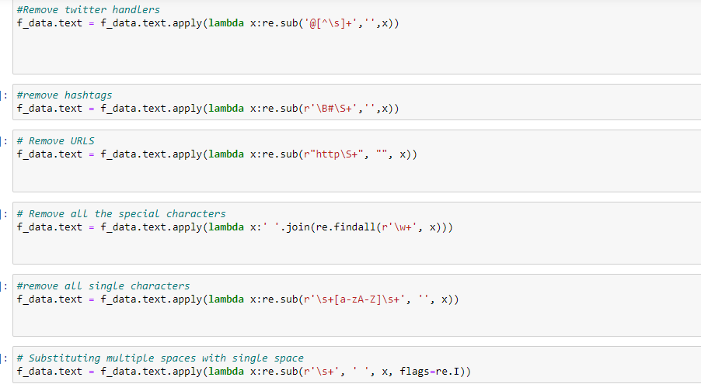

After Using this we wil get the output like this

* When we count the Flag type of data in the set then we will plot a graph for that we use an Index function to create a table for to achieve the below code.

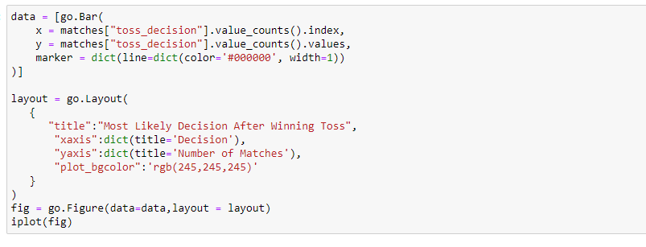

By implementing the above code we see the output like below

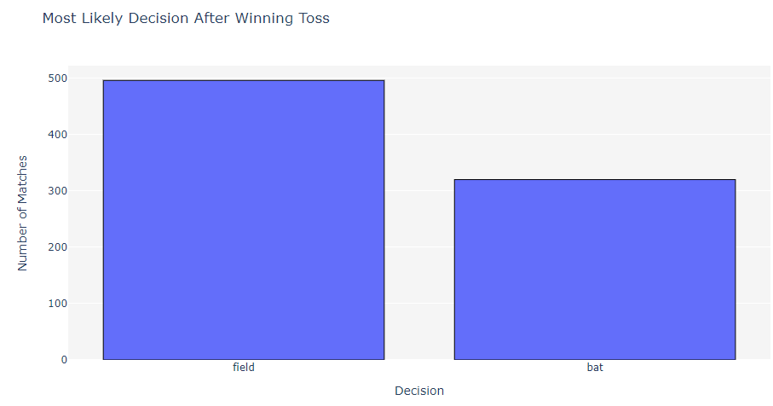

* Sorting: A DataFrame can be sorted by the value of one of the variables (columns), we can sort by Total day charge (use ascending=False to sort in descending order):

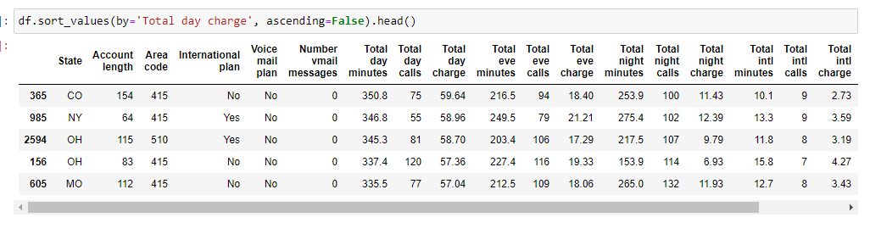

Below Image we can use the multiple Sort Column

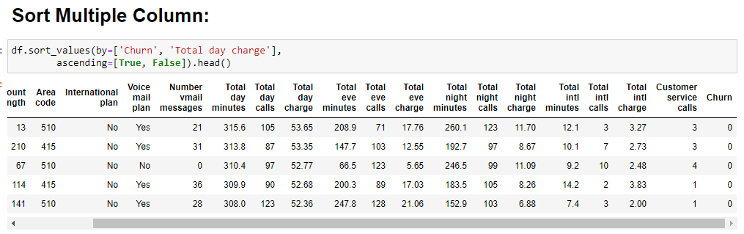

Extracting the Particular Record from the data Use the Below Code by Using the Numpy Function.

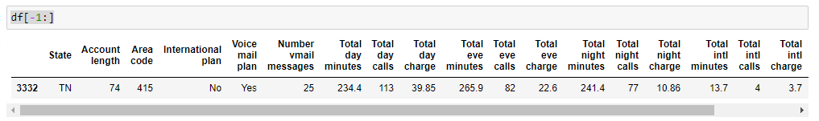

This function acts as a filter here we can filter the state wise data giving a starting letter=W

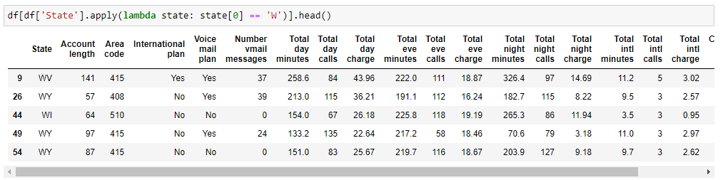

* Grouping

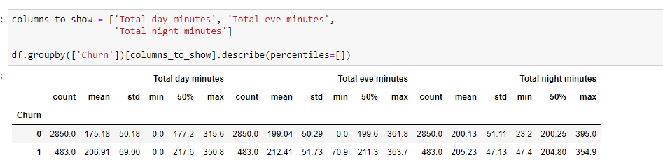

* Using the Pivot We can use this type of code

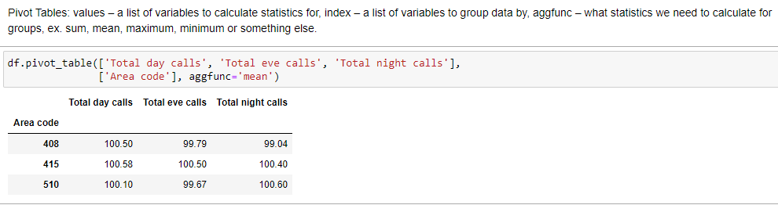

* Data Frame Transformation adding the custom Column in to our data set based on some calculation use this type of scenario

